EXPERIMENT – 9

EXP No: 9

Date: ___________

Title
JOINS (INNER JOIN, LEFT JOIN, RIGHT JOIN)

AIM
To perform INNER JOIN, LEFT JOIN, and RIGHT JOIN operations on the Drone Delivery Management System database.3

DESCRIPTION
Joins combine rows from two or more tables based on a related column.
- INNER JOIN – Returns matching records from both tables.
- LEFT JOIN – Returns all records from the left table and matching records from the right table.
- RIGHT JOIN – Returns all records from the right table and matching records from the left table.

PROCEDURE
- Open MySQL Command Line.
- Select the DroneDelivery database.
- Execute JOIN queries.
- Display the combined records.

Query 1

USE DroneDelivery;



Query 2

SELECT

C.CustomerID,

C.CustomerName,

D.DeliveryID,

D.Destination

FROM Customers C

INNER JOIN Deliveries D

ON C.CustomerID=D.CustomerID;

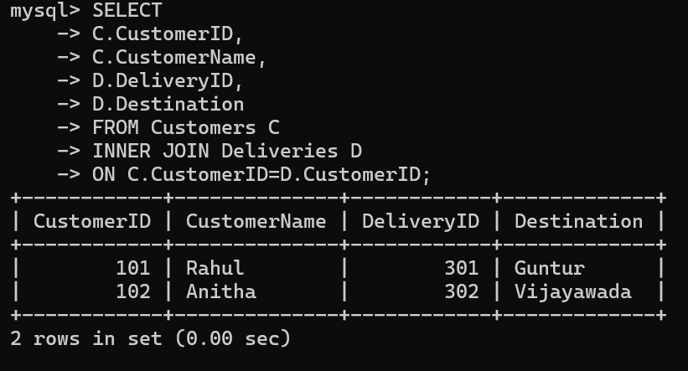

Query 3

SELECT

C.CustomerName,

R.DroneModel,

D.Destination,

D.DeliveryStatus

FROM Customers C

INNER JOIN Deliveries D

ON C.CustomerID=D.CustomerID

INNER JOIN Drones R

ON D.DroneID=R.DroneID;

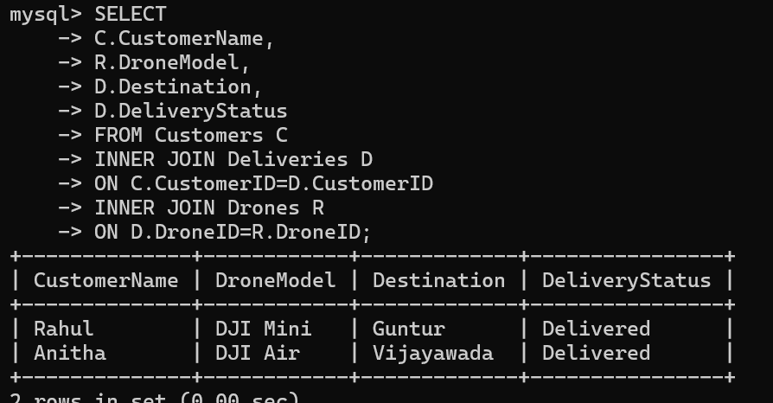

Query 4

SELECT

C.CustomerName,

D.DeliveryID

FROM Customers C

LEFT JOIN Deliveries D

ON C.CustomerID=D.CustomerID;

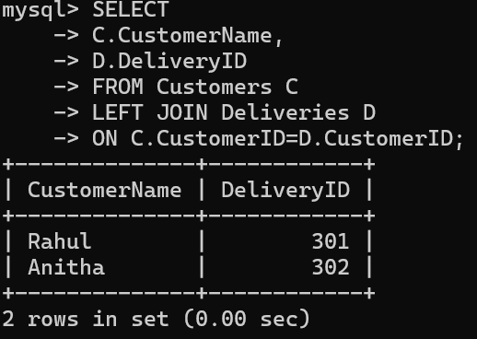

Query 5

SELECT

C.CustomerName,

D.DeliveryID

FROM Customers C

RIGHT JOIN Deliveries D

ON C.CustomerID=D.CustomerID;

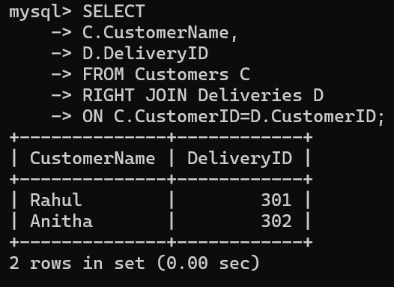

Query 6

SELECT

C.CustomerName,

R.DroneModel

FROM Customers C

INNER JOIN Deliveries D

ON C.CustomerID=D.CustomerID

INNER JOIN Drones R

ON D.DroneID=R.DroneID;

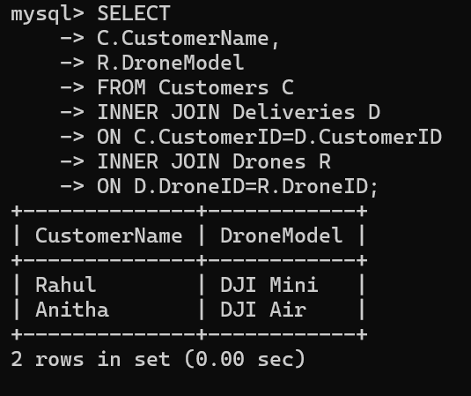

Query 7

SELECT

C.CustomerName,

D.DeliveryStatus

FROM Customers C

INNER JOIN Deliveries D

ON C.CustomerID=D.CustomerID;

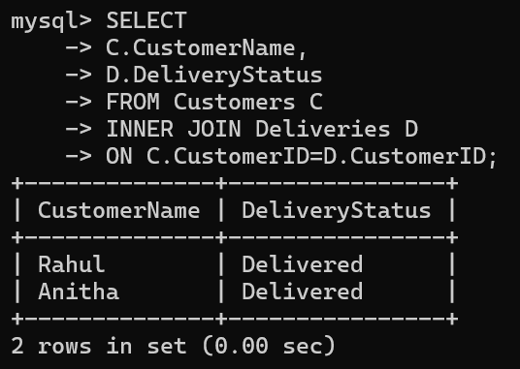

Query 8

SELECT

C.CustomerName,

R.DroneModel,

R.DroneStatus

FROM Customers C

INNER JOIN Deliveries D

ON C.CustomerID=D.CustomerID

INNER JOIN Drones R

ON D.DroneID=R.DroneID;

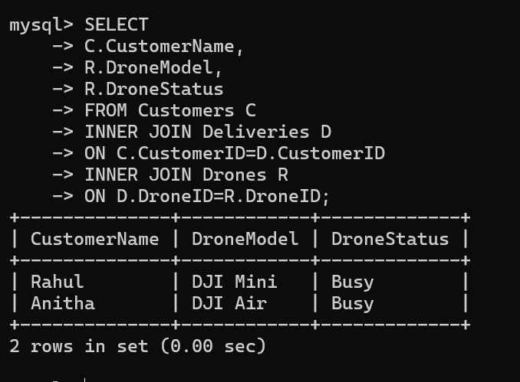

Query 9

SELECT

D.Destination,

R.DroneModel

FROM Deliveries D

INNER JOIN Drones R

ON D.DroneID=R.DroneID;

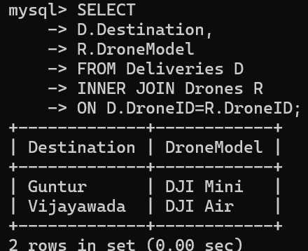

Query 10

SELECT

C.CustomerName,

R.DroneModel,

D.Destination,

D.DeliveryDate,

D.DeliveryStatus

FROM Customers C

INNER JOIN Deliveries D

ON C.CustomerID=D.CustomerID

INNER JOIN Drones R

ON D.DroneID=R.DroneID;
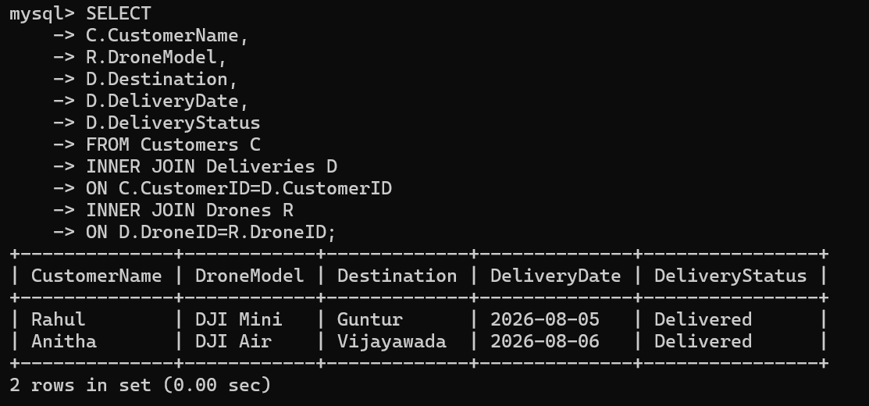

RESULT
Thus, the INNER JOIN, LEFT JOIN, and RIGHT JOIN operations were successfully executed on the Drone Delivery Management System database.

